**COMP229 – Web Application Development**

**Midterm**

**COMPONENT-JSX- REACT FORMS**

Due Week #7

# Value 15%

COMPONENTS, JSX, REACT FORMS **Maximum Mark: 100**

**Overview**: Create a react JSX form as shown below, ensure the form is functional.

1.



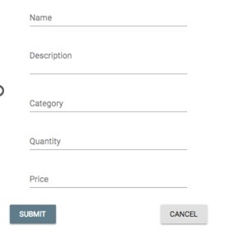

**SUBMITTING YOUR WORK**

Your submission should include:

1. A zip archive of your form files
2. A link to GitHub
3. A word doc. Showing the snapshots

This Midterm Test is weighted **15%** of your total mark for this course.

